**Assignment 1] ReactJS Spring Boot CRUD Full Stack App**

In this full-stack project, we will learn how to develop a simple end-to-end full-stack web application that is basic **Employee Management Application**using React, Spring Boot.

I have created this project for my free **ReactJS + Spring Boot CRUD Full Stack App** course on YouTube.

We will build two projects:

1. **sprintboot-backend (server)** – To develop REST API
2. **react-frontend (client)** – Consume REST API

In this project, you will learn how to build a full-stack web application that is basic **Employee Management Application with**CRUD features:

* Create Employee
* List Employee
* Update Employee
* Delete Employee
* View Employee

Following is the screenshot of the final version of our application –

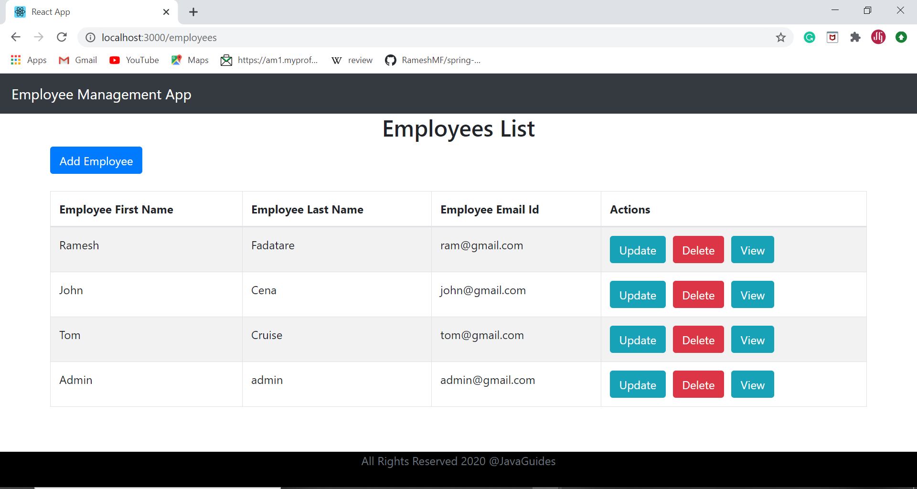

**2] Employee Management System App (Spring Boot + Angular 8 CRUD)**

A simple *Employee Management System* App is developed using Spring Boot and Angular 8. Here we will learn how to develop a CRUD (Create, Read, Update, Delete) Web Application using Angular 8 as a front-end and **Spring boot** 2 restful API as a backend.

* Create an Employee
* Update an Employee
* List of Employees
* Delete Employee
* View Employee

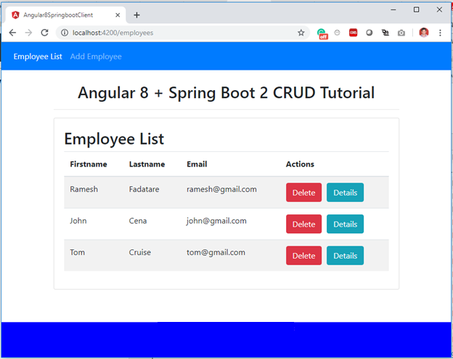

## 3] Shopping Cart App

This is a **shopping cart application**developed using Microservice Architecture with Spring Boot, Spring Cloud.

Here are the microservices:

1. **catalog-service:** It provides REST API to provide catalog information like products.
2. **inventory-service:** It provides a REST API to manage product inventory.
3. **cart-service:** It provides a REST API to hold the customer cart details.
4. **order-service:**It provides a REST API to manage orders.
5. **customer-service:** It provides a REST API to manage customer information.
6. **shoppingcart-ui:** It is a customer-facing front-end web application.